|  |  |  |  |  |  |  |  |  |  |
| --- | --- | --- | --- | --- | --- | --- | --- | --- | --- |
|  | | | | | | | | | |
|  | Report on Lab-07  DATABASE MANAGEMENT SYSTEMS LAB | | | | | |  | |
|  |  | | | | | | |  | | |
| Submitted by  Adid-Al-Mahamud Shazid  Student Id: 210042172  Department: CSE  Programme: SWE  Course Title: CSE 4308  Submitted to  Zannatun Naim Sristy  Lecturer, Department of CSE  September 28, 2023 | |  | | | | |
|  |
|  | | |  |
|  | |  | | | |  | | | |

**Introduction**

In the lab class, we were asked to draw an ER Diagram by analysing a given problem set.

**Task**

We are Booked (WB) is the legal depository of all new books and other printed materials in Bangladesh. Previously they stored all their information in papers. Recently they have decided to use a database. They have come up with the following requirements:

• There are many branches of WB in different locations in the country. Each branch has its unique branch ID, location, and year of establishment.

• Every branch is maintained by some employees. During the recruitment process, the National ID (NID), name, blood group, and birth date are stored. WB has three types of employees, namely Admin, Librarian, and Maintenance. Each has a separate base salary and 40% housing allowance based on the base salary.

• The employees work in different shifts in different branches. Each shift starts at a certain time on a specific day of the week. It also has a fixed duration.

• Of course the branches house many books. Each book can be identified by a 13-digit ISBN number. The name, author, genre, and price of the books are also stored. The number of copies of a book for each branch should be also tracked efficiently.

• Each book comes from different publishers. The publishers have their name, city, and establishment year. Note that, the same city will not have more than one publisher with the same name.

• To issue a book from any branch, a user has to create an account, providing their unique username. In addition to that, the user’s name, date of birth, hometown, and occupation are also stored.

• When a book is issued by a user, the employee sets the issue date and number of days the user can keep the book. It might happen that sometimes the employee forgets to put the duration. In that case, the book should be returned within 15 days. Additionally, information about the user, book, and employee involved needs to be tracked for future purposes.

Now, your task is to:

1. Draw an ER Diagram, without any data redundancy, specifying the cardinality explicitly. You may add additional attributes only if it is needed.

2. Convert the ER Diagram into DDL using standard SQL denoting the appropriate constraints.

1. **1 Solution**

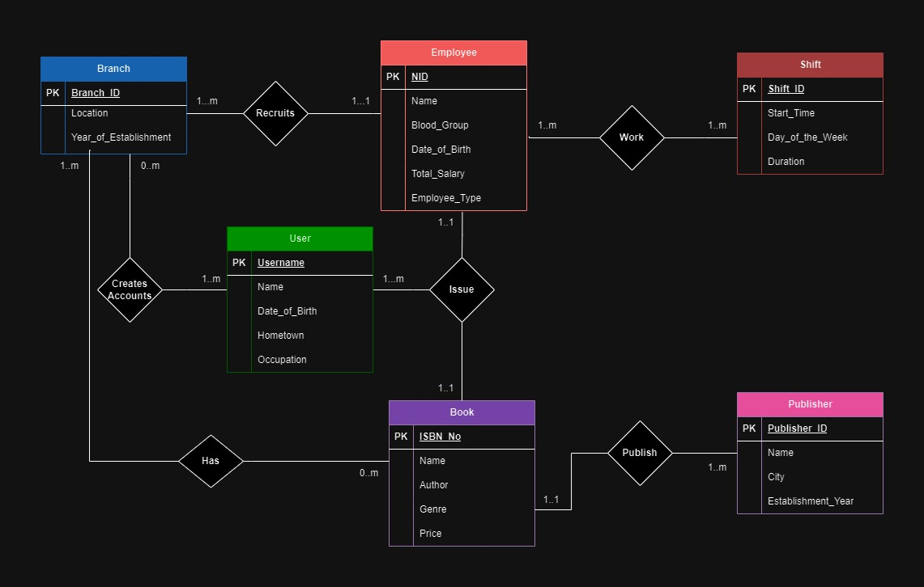

1. **2 Analysis and Explanation**

Using ERD Diagram I connected the mentioned entities according to the relations I found between them getting help from the pdf.

1. **3 Difficulties**

I faced difficulties in figuring out how each entity is connected to one another and what the relationship is between them. No other mentionable issues were encountered.

1. **1 Solution**
2. CREATE TABLE Branch (
3. Branch_ID INT NOT NULL,
4. Location VARCHAR2(50) NOT NULL,
5. Year_of_Establishment INT NOT NULL,
6. CONSTRAINT PK_Branch PRIMARY KEY(Branch_ID)
7. );
8. CREATE TABLE Employee (
9. Employee_ID INT NOT NULL,
10. National_ID VARCHAR2(20) UNIQUE,
11. Name VARCHAR2(50) NOT NULL,
12. Blood_Group VARCHAR2(2) NOT NULL,
13. Date_of_Birth DATE NOT NULL,
14. Employee_Type VARCHAR2(20) NOT NULL,
15. Branch_ID INT NOT NULL,
16. CONSTRAINT PK_Employee PRIMARY KEY(Employee_ID),
17. CONSTRAINT FK_Branch FOREIGN KEY (Branch_ID) REFERENCES Branch(Branch_ID)
18. );
19. CREATE TABLE Shift (
20. Shift_ID INT NOT NULL,
21. Start_Time TIME NOT NULL,
22. Day_of_the_Week VARCHAR2(10) NOT NULL,
23. Duration TIME NOT NULL,
24. CONSTRAINT PK_Shift PRIMARY KEY(Shift_ID)
25. );
26. CREATE TABLE Book (
27. ISBN VARCHAR(13) NOT NULL,
28. Title VARCHAR2(50) NOT NULL,
29. Author VARCHAR2(50) NOT NULL,
30. Genre VARCHAR2(50) NOT NULL,
31. Price DECIMAL(10, 2) NOT NULL,
32. Publisher_ID INT NOT NULL,
33. CONSTRAINT PK_Book PRIMARY KEY(ISBN),
34. CONSTRAINT FK_Publisher FOREIGN KEY (Publisher_ID) REFERENCES Publisher(Publisher_ID)
35. );
36. CREATE TABLE Publisher (
37. Publisher_ID INT NOT NULL,
38. Name VARCHAR2(50) NOT NULL,
39. City VARCHAR2(50) UNIQUE,
40. Establishment_Year INT NOT NULL,
41. CONSTRAINT PK_Publisher PRIMARY KEY(Publisher_ID),
42. );
43. CREATE TABLE User (
44. Username VARCHAR(50) NOT NULL,
45. Name VARCHAR2(50) NOT NULL,
46. Date_of_Birth DATE NOT NULL,
47. Hometown VARCHAR2(50) NOT NULL,
48. Occupation VARCHAR2(50) NOT NULL,
49. CONSTRAINT PK_User PRIMARY KEY(Publisher_ID)
50. );
51. CREATE TABLE Issue (
52. Issue_ID INT NOT NULL,
53. Branch_ID INT NOT NULL,
54. Employee_ID INT NOT NULL,
55. ISBN VARCHAR(13) NOT NULL,
56. Username VARCHAR(50) NOT NULL,
57. Issue_Date DATE NOT NULL,
58. Duration INT NOT NULL,
59. CONSTRAINT PK_Issue PRIMARY KEY(Issue_ID)
60. CONSTRAINT FK_Issue_Branch FOREIGN KEY (Branch_ID) REFERENCES Employee(Branch_ID),
61. CONSTRAINT FK_Employee FOREIGN KEY (Employee_ID) REFERENCES Employee(Employee_ID),
62. CONSTRAINT FK_Book FOREIGN KEY (ISBN) REFERENCES Book(ISBN),
63. CONSTRAINT FK_User FOREIGN KEY (Username) REFERENCES User(Username)
64. );
65. CREATE TABLE Accounts (
66. Branch_ID INT NOT NULL,
67. Username VARCHAR(50) NOT NULL,
68. CONSTRAINT FK_Branch_Account FOREIGN KEY (Branch_ID) REFERENCES Branch(Branch_ID),
69. CONSTRAINT FK_User_Account FOREIGN KEY (Username) REFERENCES User(Username)
70. );
71. CREATE TABLE Booklist (
72. Branch_ID INT NOT NULL,
73. ISBN VARCHAR(13) NOT NULL,
74. No_of_Books INT NOT NULL,
75. CONSTRAINT FK_Branch_Booklist FOREIGN KEY (Branch_ID) REFERENCES Branch(Branch_ID),
76. CONSTRAINT FK_Book_Booklist FOREIGN KEY (ISBN) REFERENCES Book(ISBN)
77. );
78. CREATE TABLE Weekly_Shift_Schedule(
79. Employee_ID INT NOT NULL,
80. Shift_ID INT NOT NULL,
81. CONSTRAINT FK_Employee_Shift FOREIGN KEY (Employee_ID) REFERENCES Employee(Employee_ID),
82. CONSTRAINT FK_Shift_Shift FOREIGN KEY (Shift_ID) REFERENCES Shift(Shift_ID)
83. );
84. **2 Analysis and Explanation**

I made a ddl using the ERD of task- 01. For every one to many relation I used foreign key reference for a primary key. Also, for every many to many relationship I made a new table combining the entities. Thus 4 new tables are formed from which the ‘Issue’ table was mentioned in the task.

1. **3 Difficulties**

I didn’t face any mentionable difficulties in this task.